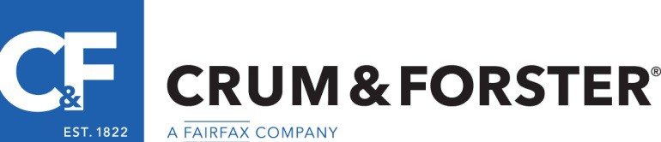

Regional Senior Risk Engineering Property/Casualty Consultant Positions
Texas - remote home base
If you are experienced in multi-line insurance loss prevention and seeking advanced opportunities to consult with moderate risk clients and work closely with “high flying” underwriting and claims teams for impact – this job is for you! Contribution to Team results and synergy are key business objectives at C & F. C & F has been recognized as one of the “Best Places to Work” by Business Insurance.
Crum & Forster is a multi-line commercial insurance carrier based in Morristown, NJ. Regional Senior Risk Engineering Property/Casualty Consultants with property and casualty skills are being sought to provide large/middle market on site prospective and newly bound account surveys, as well as service to existing clients. This unique opportunity emphasizes communication and collaboration with the internal underwriting and claims team for the achievement of profitability and loss containment goals. C & F Risk Engineering develops and implements client service plans and supports client compliance with focused risk improvement recommendations so consultative skills are important. Innovative project work expanding client resources and offerings is also a highlight for 2019/2020 and factored into workload requirements. These jobs present a great opportunity to shape and market the C & F Risk Engineering footprint and service portfolio. http://www.cfins.com/about-us/
A company car accompanies the position. Field work radius ranges from daily drivable distances to 1 to 2 overnight trips (auto or flight) monthly to large account locations. The report platform in use is LC 360.
Minimum requirements include;

- 7 -15 years of experience
- College degree in a related discipline
- Certified Safety Professional designation
- Familiarity with usage and applications of NFPA 13 and 30
- Liability, products liability, auto liability, and workers’ compensation experience
- Basic industrial hygiene skills - a plus
- Loss analysis skills
- Presentation skills
Please send all inquiries and resumes to louise.vallee@cfins.com or call 973-490-6682.

